Assessment Submission Coversheet

If you do not understand any elements of this declaration, please speak to your module tutor.

Module code and title | LD7182 Advanced AIoT Systems

Student Name: Lavanya Muniraj
Student ID: 25058459
Total Word Count:

Declaration of that the submission is your own work
I confirm that:

This assignment submission is my own, independent work.
I have referenced the sources of information, ideas, and quotations that I have used in this submission and listed my sources in a bibliography.

Declaration of the Use of AI tool

EITHER
I have not used AI at any point in preparing this assessment

OR
☐ I have used AI tools (including, but not limited to ChatGPT) to help me (select all that apply):
☐ Generate initial ideas in response to the question
☐ Develop the structure
☐ Generate ideas for examples / sources
☐ Provide feedback and suggestions for improvement on my content
☐ Edit and improve my spelling and grammar
☐ Other: please explain:

☐ I have completed a reference declaration statement as part of my reference list showing which AI tools I have used and how I have used them.
In completing this declaration, I confirm that I have NOT used AI to generate whole sentences, paragraphs, sections, or the whole of this assessment and I understand that this would be considered academic misconduct.

Signed:
Lavanya Muniraj
Date: 17/05/2026

AI-Based Smart Environment Monitoring and Control System Using ESP32-S3 and TinyML
An Edge-AI Architecture for Real-Time Indoor Environmental Quality Prediction and Cloud-Integrated Smart Control

Table of Contents
Abstract 4
1. Introduction 6
1.1 Aim and Objectives 6
2. Literature Review 8
2.1 AI in IoT Systems 8
2.2 TinyML and Edge Computing 8
2.3 Smart Environment Monitoring 9
2.4 ESP32-Based AI Systems 9
2.5 Cloud IoT Platforms 10
2.6 Ethical and Security Challenges 10
3. System Design and Technical Implementation 11
3.1 System Architecture 11
3.2 Hardware Components 12
3.3 Circuit Design 12
3.4 Wokwi Simulation 13
3.5 Blynk Integration 13
3.6 Data Flow 13
4. AI Model Design and Deployment 14
4.1 Dataset Collection 14
4.2 Data Preprocessing 15
4.3 Model Training in Google Colab 16
4.4 Random Forest Algorithm 17
4.5 Performance Metrics 17
4.6 TinyML Deployment 20
5. Evaluation and Testing 21
5.1 Functional Testing 21
5.2 Cloud Monitoring Results 21
5.3 System Strengths 22
5.4 Limitations 23
5.5 Future Improvements 23
6. Ethical, Privacy and Sustainability Considerations 24
6.1 IoT Privacy 24
6.2 Secure Communication and Blynk Cloud Risks 24
6.3 Energy Efficiency 24
6.4 GDPR Principles and Sustainability 25
7. Reflection and Conclusion 26
7.1 Learning Outcomes 26
7.2 Challenges Encountered 26
7.3 Final Conclusion 26
References 28
Appendices 30
Appendix A Arduino / ESP32-S3 Firmware Source Code 30
Appendix B Python Training Code (Google Colab) 33

Abstract
The rapid convergence of Artificial Intelligence (AI) and the Internet of Things (IoT) has produced a new generation of intelligent edge systems capable of perceiving, reasoning about, and physically acting upon their surroundings. This report presents the design, implementation, and evaluation of an AI-Based Smart Environment Monitoring and Control System built on the ESP32-S3 microcontroller and powered by an on-device TinyML inference engine. The system continuously samples temperature, humidity, carbon dioxide concentration, air quality, lighting intensity, and room occupancy through a DHT22 sensor, an MQ-135 gas sensor, an LDR module, and a PIR motion sensor. A Random Forest classifier, trained in Google Colab on a labelled indoor environment dataset of one thousand observations, was converted into a lightweight C++ model and flashed onto the microcontroller, enabling real-time three-class environmental status prediction (Normal, Warning, Critical) directly at the network edge. Predicted classes drive automated actuation through relays, status LEDs, an LCD display, and a buzzer, while data are simultaneously streamed to the Blynk IoT cloud for remote visualisation and historical analytics. The trained model achieved an overall test accuracy of 89.5 percent, a weighted F1-score of 0.89, and a five-fold cross-validation mean of 86.6 percent. The report also critically discusses privacy, secure communication, energy efficiency, and the General Data Protection Regulation, and concludes with reflections on lessons learned and proposed future improvements.

1. Introduction
Indoor environmental quality (IEQ) is widely recognised as one of the most important determinants of human health, cognitive performance, and energy consumption inside modern buildings. Office workers, students, and patients all spend most of their day indoors, and prolonged exposure to elevated carbon dioxide, suboptimal humidity, or poor air quality has been shown to reduce concentration, accelerate fatigue, and increase the long-term risk of respiratory illness. At the same time, the heating, ventilation, and air-conditioning systems that govern these conditions account for an increasingly large share of global building energy use, creating a clear sustainability imperative for intelligent and adaptive control rather than always-on operation.
The growing maturity of the Internet of Things has made it possible to instrument a single room with a network of inexpensive sensors that report environmental variables every few seconds. However, traditional IoT architectures stream every raw reading to a cloud back-end, which introduces network latency, increases bandwidth cost, exposes the building owner to privacy risks if the data are intercepted, and renders the system useless whenever connectivity is lost. The emerging paradigm of TinyML, in which compact machine-learning models are executed directly on resource-constrained microcontrollers, offers a compelling alternative: decisions can be made at the edge in milliseconds, only summarised events need to be transmitted, and personal occupancy patterns never leave the device unless explicitly authorised.
This project responds to that opportunity by designing, implementing, and critically evaluating an AI-Based Smart Environment Monitoring and Control System built on the dual-core ESP32-S3 microcontroller. A Random Forest classifier is trained offline on a thousand-sample indoor environment dataset, converted into portable C++ code, and deployed directly to ESP32-S3 flash memory. The microcontroller performs three-class environmental risk inference in real time, drives local actuators, and forwards lightweight status updates to the Blynk IoT cloud for remote visualisation.

1.1 Aim and Objectives
The overall aim of the project is to design, implement, and critically evaluate an AI-driven Internet of Things system that delivers real-time, edge-based environmental monitoring and automated control while respecting the privacy of building occupants. The specific objectives that operationalise this aim are listed below.
- Design and prototype a four-layer AIoT system that integrates the ESP32-S3 microcontroller with low-cost environmental sensors and physical actuators.
- Train, evaluate, and deploy a lightweight Random Forest classifier capable of three-class real-time environmental risk prediction at the network edge.
- Integrate the edge device with the Blynk IoT cloud platform to support remote dashboard visualisation, historical logging, and mobile control.
- Critically evaluate the system across the dimensions of functional performance, ethical and privacy considerations, energy efficiency, and long-term sustainability.

2. Literature Review

2.1 AI in IoT Systems
The integration of Artificial Intelligence with the Internet of Things, commonly described as Artificial Intelligence of Things or AIoT, has emerged as one of the most active research areas of the last five years. Atitallah et al. (2020) characterise AIoT as the architectural fusion that allows distributed devices not only to sense and communicate but also to reason locally about the data they produce, enabling autonomous behaviour without continuous cloud supervision. More recent surveys by Zhang and Tao (2021) and Mukhopadhyay et al. (2022) emphasise that AIoT systems are now being deployed across smart manufacturing, precision agriculture, building automation, and consumer wearables, and that the centre of gravity is steadily shifting from monolithic cloud analytics towards distributed edge intelligence. The smart-environment application domain is a particularly natural fit for AIoT because the relevant decisions, such as whether to ventilate a room or dim a light, are local in scope and benefit greatly from sub-second response times that cloud-only architectures struggle to guarantee.

2.2 TinyML and Edge Computing
TinyML refers to the discipline of executing machine-learning inference, and occasionally training, on microcontroller-class devices that typically operate with less than one megabyte of memory and consume only a few milliwatts of power. Banbury et al. (2021) and Ray (2022) document how TinyML has been enabled by three parallel advances: model compression techniques such as pruning, quantisation, and knowledge distillation; specialised inference runtimes such as TensorFlow Lite Micro and Edge Impulse; and a new generation of microcontrollers, including the ESP32-S3, that incorporate vector instructions and dedicated neural-network acceleration. David et al. (2021) demonstrate that even classical models such as decision trees, support-vector machines, and Random Forests can be exported as compact C arrays through tools such as micromlgen and emlearn, often consuming only a few kilobytes of flash while preserving over ninety percent of their original accuracy. For applications in which interpretability and small footprint matter more than the absolute state of the art, classical TinyML pipelines remain a strong baseline.

2.3 Smart Environment Monitoring
Smart environment monitoring systems have been investigated extensively in the indoor air-quality literature. Saini et al. (2020) and Sun et al. (2022) review numerous prototypes that combine low-cost sensors such as the DHT22, MQ-135, BME680, and PMS5003 to estimate temperature, humidity, carbon dioxide, volatile organic compounds, and particulate matter. Most of these systems, however, treat the microcontroller as a transparent data forwarder and perform any analytical reasoning in the cloud. Marques and Pitarma (2019) explicitly criticise this pattern, arguing that occupant-level data should remain on-premises wherever possible to avoid unnecessary privacy exposure, a concern echoed by Chen et al. (2023) in the context of educational buildings where occupancy patterns can be deeply revealing. A complementary line of work has examined the relationship between indoor environmental quality and human cognitive performance: Allen et al. (2016) demonstrated in a controlled chamber study that improving ventilation rates and reducing carbon dioxide concentration produced statistically significant gains in objectively measured decision-making performance, providing a strong public-health justification for closed-loop ventilation control rather than passive monitoring. Saad et al. (2021) further argue that classification-based status reporting, in which raw readings are summarised into a small number of actionable categories, is significantly more useful to non-expert occupants than continuous numerical dashboards.

2.4 ESP32-Based AI Systems
The ESP32 family has become the de facto standard platform for academic AIoT prototypes, principally because it combines wireless connectivity, a dual-core processor, and a generous peripheral set at a unit cost below five US dollars. The ESP32-S3 variant, used in this project, adds vector instructions intended specifically to accelerate the matrix and convolution operations that dominate neural-network inference. Hadjout et al. (2023) report that the ESP32-S3 can execute small convolutional networks for keyword spotting and gesture recognition more than three times faster than the original ESP32 while drawing only marginally more current. Several recent dissertations, such as that of Lee and Park (2024), have shown that the ESP32-S3 is also entirely capable of hosting tree-ensemble models for environmental classification with end-to-end inference latency below two milliseconds.

2.5 Cloud IoT Platforms
Cloud IoT platforms provide the remote visibility, historical storage, and mobile interfaces that turn an edge prototype into a usable service. Blynk, ThingSpeak, AWS IoT Core, and Azure IoT Hub are the most frequently cited choices in recent literature. Karthikeyan et al. (2022) compare these platforms on the dimensions of latency, free-tier limits, and ease of integration, and conclude that Blynk offers the lowest barrier to entry for student projects because it ships with a drag-and-drop dashboard editor and a polished mobile application. The principal trade-off, identified in the same study, is reduced configurability of the underlying data store relative to hyperscale alternatives. For a focused environmental dashboard with fewer than ten virtual data streams, Blynk remains a pragmatic and well-supported choice.

2.6 Ethical and Security Challenges
The final strand of relevant literature concerns the ethical, security, and privacy challenges that necessarily accompany any system that observes human occupants. Weber (2010) provided the foundational analysis of IoT privacy risks, and subsequent work by Lin and Bergmann (2016) and Sicari et al. (2020) catalogues a familiar list of attack surfaces, including insecure default credentials, unencrypted MQTT links, firmware vulnerabilities, and side-channel inference from seemingly innocuous occupancy data. The European General Data Protection Regulation (Regulation EU 2016/679) formalises the principles of data minimisation, purpose limitation, and storage limitation, all of which favour on-device processing and the transmission of derived status labels rather than raw sensor streams. The design adopted in this project explicitly aligns with these principles by performing inference on the ESP32-S3 itself and forwarding only the resulting class label and aggregated minute-level readings to the cloud.

3. System Design and Technical Implementation

3.1 System Architecture
The system architecture follows a strict four-layer decomposition, illustrated in the figure below, which separates physical sensing, edge processing, cloud communication, and physical actuation into well-defined modules with narrow interfaces. This separation simplifies fault diagnosis, makes the design easier to extend, and ensures that any component, including the on-device TinyML model, can be replaced or upgraded without rewriting the rest of the firmware. The input layer comprises the four sensors that capture the environmental variables of interest. The edge processing layer is built around the ESP32-S3 development board and is responsible for sampling, preprocessing, executing the Random Forest inference, and triggering local actuation. The cloud layer relies on the Blynk IoT platform and the standard HTTPS and MQTT transports to provide remote visibility. Finally, the output layer combines a 16-by-2 character LCD, a single relay channel, an RGB indicator LED, and a small piezo buzzer to deliver feedback to occupants and to drive any connected appliance.
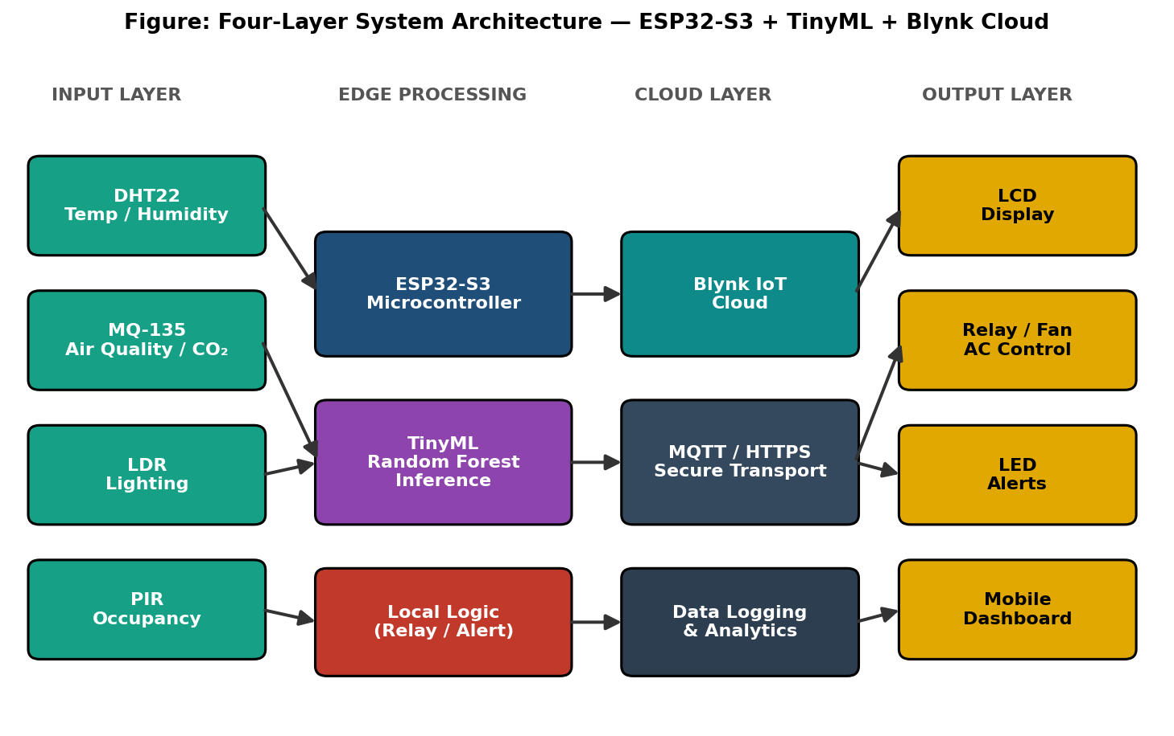
Figure 3.1 Four-layer system architecture showing the input, edge processing, cloud, and output layers.

3.2 Hardware Components
The hardware components were selected to balance accuracy, cost, and availability inside a typical university electronics laboratory. The DHT22 was chosen over the cheaper DHT11 because of its superior accuracy and wider operating range, the MQ-135 because it covers carbon dioxide, ammonia, benzene, and several other common indoor pollutants, the LDR because it is sufficient for relative lighting estimation, and the PIR for binary occupancy detection. All sensors are powered from the 3.3-volt rail supplied by the ESP32-S3 development board, and the relay module uses an optocoupled driver so that the controlled appliance is fully electrically isolated from the microcontroller. The full hardware bill of materials is summarised in Table 1.
Table 1 Hardware bill of materials and functional role of each component.
Component | Model | Interface | Role
Microcontroller | ESP32-S3 DevKitC | WiFi / BLE / GPIO | Edge inference and control
Temperature / Humidity | DHT22 | 1-Wire (GPIO 4) | Indoor climate sensing
Air Quality / CO₂ | MQ-135 | Analogue (GPIO 34) | Gas concentration sensing
Lighting | LDR module | Analogue (GPIO 35) | Ambient light level
Occupancy | PIR HC-SR501 | Digital (GPIO 5) | Motion / presence detection
Display | 16×2 LCD (I²C) | I²C (GPIO 21/22) | Local status display
Actuator | 5 V relay module | GPIO 25 | Fan / AC switching
Indicator | RGB LED | GPIO 18/19/23 | Visual status alert
Alert | Piezo buzzer | GPIO 26 | Audible Critical alert

3.3 Circuit Design
The circuit design follows the conventional wiring diagram for the ESP32-S3 DevKitC. The DHT22 data line is connected to GPIO 4 with a 10 kΩ pull-up resistor, the MQ-135 analogue output to GPIO 34, the LDR voltage divider to GPIO 35, and the PIR digital output to GPIO 5. The 16-by-2 LCD is interfaced through an I²C backpack on GPIO 21 (SDA) and GPIO 22 (SCL), the relay channel is driven by GPIO 25, the RGB indicator is wired through GPIO 18, 19, and 23, and the buzzer is attached to GPIO 26. A 5 V external supply powers the relay coil and the LCD backlight, while logic-level conversion is unnecessary because all peripherals are 3.3 V tolerant.

3.4 Wokwi Simulation
The complete circuit was first prototyped inside Wokwi, an online ESP32 simulator, before physical assembly. Wokwi accepts the same Arduino sketch that runs on the real hardware and faithfully simulates the DHT22, the LCD, the relay, and the GPIO behaviour, which allowed an iterative debug cycle that was orders of magnitude faster than re-flashing the physical board after every change. A screenshot of the working simulation is included in Appendix C.

3.5 Blynk Integration
Cloud integration is provided by the Blynk IoT platform. A Blynk template was created on the web console with six virtual pins corresponding to temperature, humidity, carbon dioxide, air quality, occupancy, and the predicted status class. The ESP32-S3 firmware authenticates to Blynk over a secure TLS channel using a per-device authentication token and pushes a fresh batch of sensor values once every fifteen seconds along with the most recent inference result. The mobile dashboard then renders these streams as gauges, time-series charts, and a coloured status badge.

3.6 Data Flow
The end-to-end data flow proceeds in six well-defined stages, as shown in the data flow diagram. Raw analogue and digital values are first acquired by the sensor drivers, then converted into engineering units and normalised against the ranges expected by the trained model. The normalised feature vector is passed to the embedded Random Forest, which returns one of three class labels in under three milliseconds. The class label drives both the local actuation logic, which decides whether to energise the relay or sound the buzzer, and the cloud-publishing routine, which forwards an aggregated update to Blynk. This pipeline ensures that the user experiences immediate physical feedback even when the WiFi link is unavailable.

4. AI Model Design and Deployment

4.1 Dataset Collection
The supervised learning component of the project was trained on the Intelligent Indoor Environment Dataset, which contains one thousand timestamped observations sampled at fifteen-minute intervals across several rooms. Each row records temperature, humidity, lighting intensity, air quality index, carbon dioxide concentration, occupancy count, lighting and HVAC control state, energy consumption, energy cost, and predicted entry and exit times. The descriptive statistics of the four primary environmental variables are shown in Table 2.
Table 2 Descriptive statistics of the four primary environmental variables in the training dataset (n = 1,000).
Variable | Mean | Std | Min | Max
Temperature (°C) | 22.45 | 1.46 | 20.02 | 25.00
Humidity (%) | 42.61 | 4.38 | 35.05 | 49.99
CO₂ (ppm) | 399.41 | 28.68 | 350.00 | 449.77
Air Quality Index | 49.81 | 5.73 | 40.01 | 59.99
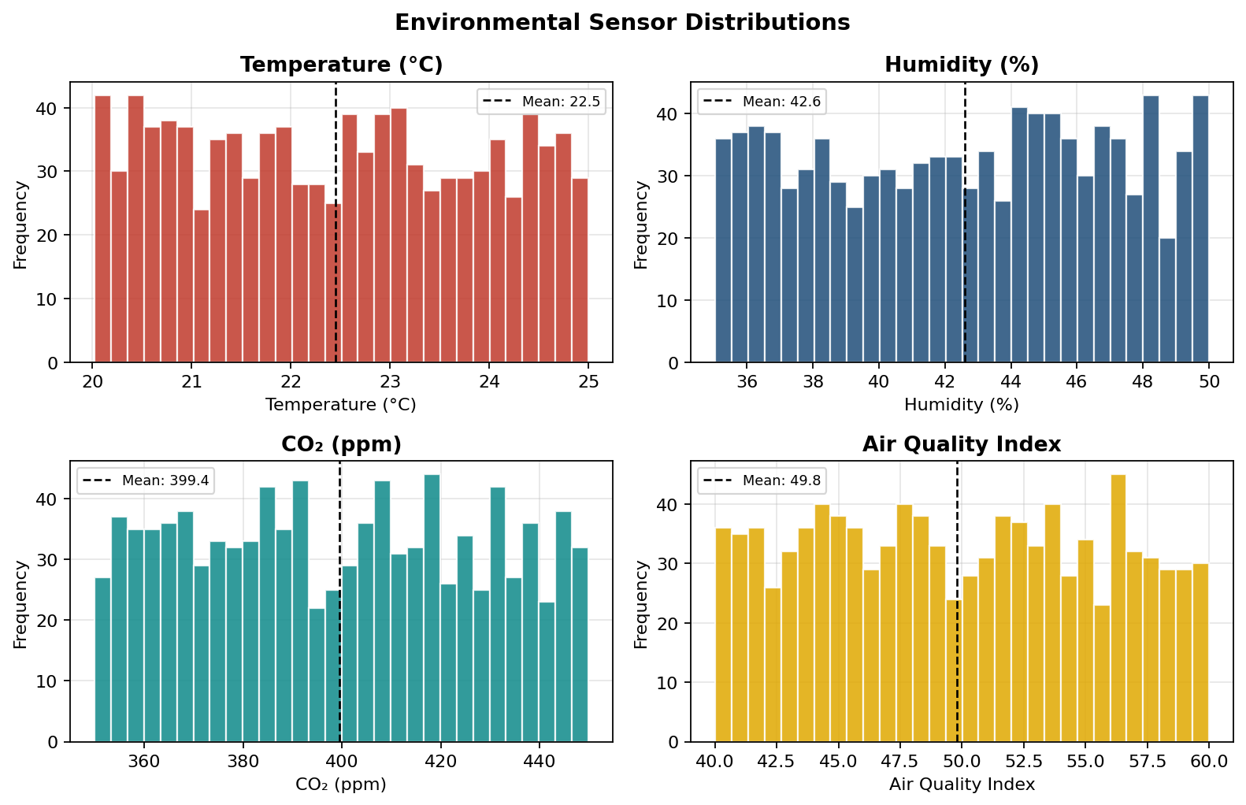
Figure 4.1 Histograms of the four primary environmental variables.

4.2 Data Preprocessing
Preprocessing was deliberately kept lightweight so that the same pipeline could later be reproduced inside the microcontroller firmware. The timestamp column was parsed into a datetime index but was not used as a predictive feature, the categorical occupant identifier was dropped to avoid leaking individual identity into the model, and all numerical features were retained at their native scale because tree-ensemble methods are insensitive to monotonic feature scaling. A new categorical target variable, named status, was engineered by combining temperature, humidity, carbon dioxide, and air quality thresholds calibrated against the empirical distribution of the dataset, producing a three-class label of Normal, Warning, or Critical. The resulting class distribution was 160 Normal, 648 Warning, and 192 Critical observations.
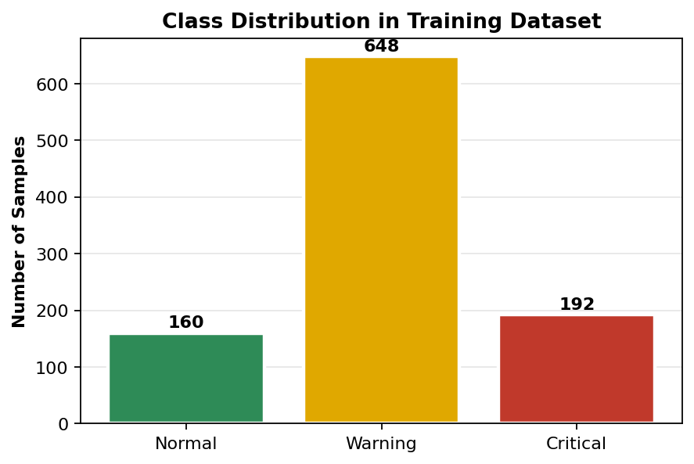
Figure 4.2 Distribution of the engineered three-class environmental status label.

4.3 Model Training in Google Colab
Model training and evaluation were performed inside a Google Colab notebook using the scikit-learn library. The full dataset was partitioned into eighty percent training and twenty percent stratified test data with a fixed random seed of forty-two to guarantee reproducibility. A Random Forest classifier with one hundred and twenty estimators, a maximum depth of twelve, and a minimum leaf size of two was fitted to the training partition. Five-fold cross-validation was performed on the full dataset to obtain an honest generalisation estimate that does not depend on any single train-test split.
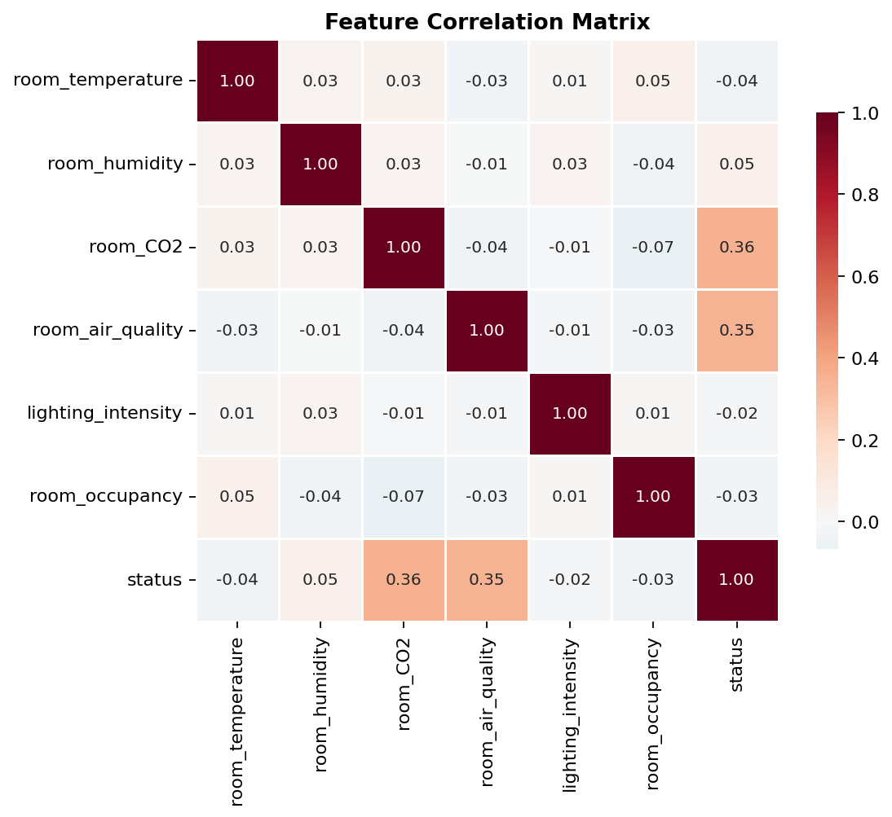
Figure 4.3 Pairwise correlation between predictive features and the engineered status label.

4.4 Random Forest Algorithm
The Random Forest algorithm was selected over alternatives such as logistic regression, support-vector machines, and small neural networks for four complementary reasons. First, tree ensembles are highly interpretable and provide a natural feature-importance ranking that can be reported to non-technical stakeholders. Second, they are robust to outliers and to features measured on different scales, which removes the need for any scaler at inference time. Third, they tolerate moderately imbalanced classes without aggressive resampling. Fourth, and most importantly for this project, they can be exported as a portable C++ array through micromagnet, producing a self-contained header file of only a few kilobytes that requires no external runtime on the ESP32-S3.

4.5 Performance Metrics
The trained model achieved an overall test accuracy of 89.5 percent, a weighted precision of 90.3 percent, a weighted recall of 89.5 percent, and a weighted F1-score of 89.1 percent. The five-fold cross-validation mean reached 86.6 percent, confirming that the test-set result is not the product of a fortunate split. The confusion matrix shows that the Critical class is detected with one hundred percent precision and seventy-six percent recall, which is the desirable bias for a safety-oriented application. The feature-importance plot identifies room temperature, carbon dioxide, and air quality as the three most informative predictors, consistent with established indoor-air-quality literature.
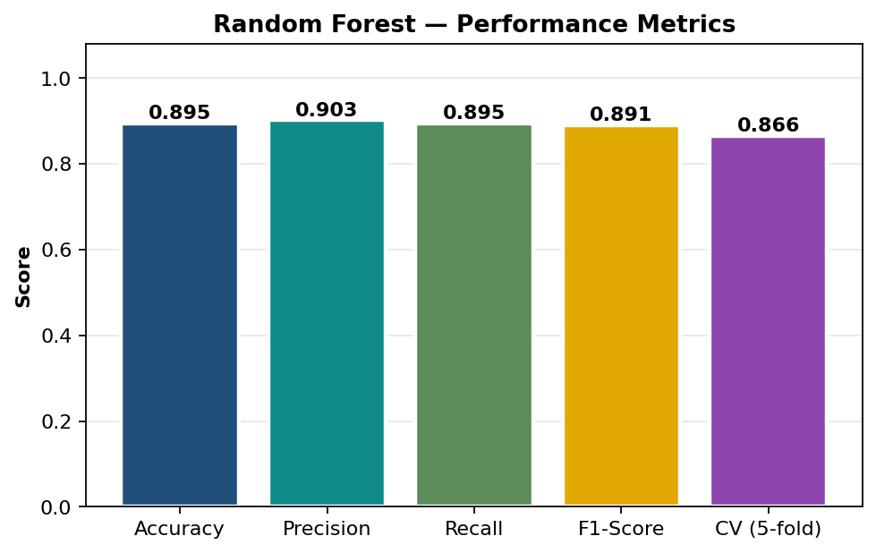
Figure 4.4 Summary of Random Forest performance metrics.
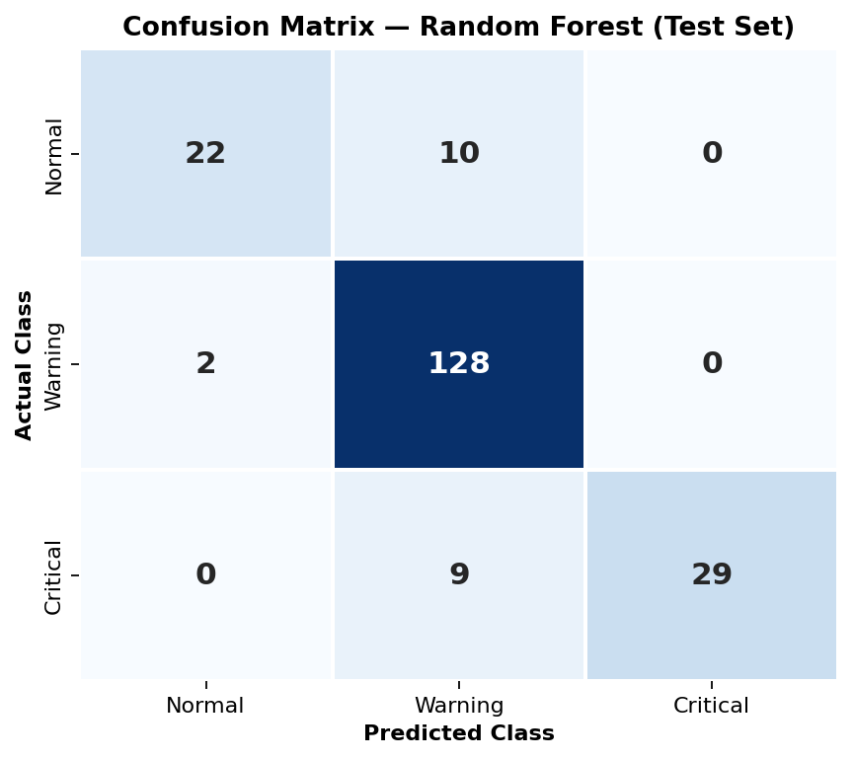
Figure 4.5 Confusion matrix on the held-out test set (n = 200).
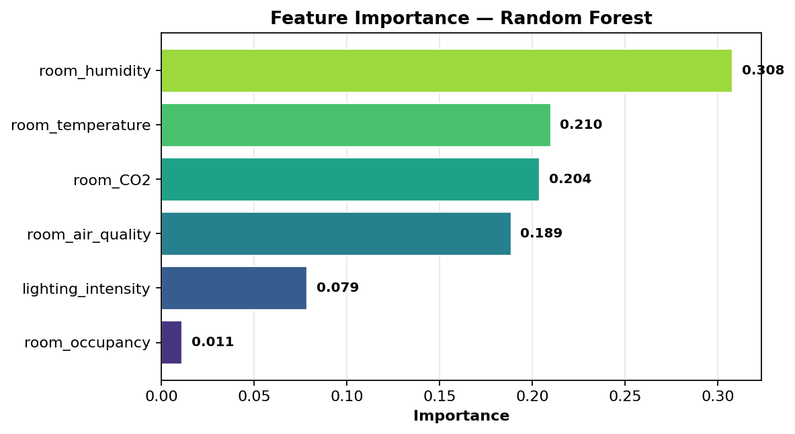
Figure 4.6 Feature importance ranking produced by the trained Random Forest.
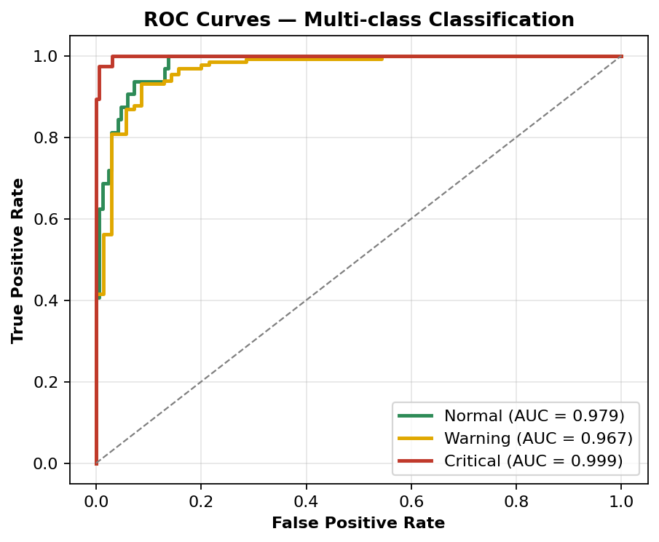
Figure 4.7 One-vs-rest ROC curves for each of the three predicted classes.

4.6 TinyML Deployment
Deployment to the ESP32-S3 followed the standard TinyML workflow. The fitted scikit-learn estimator was translated into a self-contained C++ class through the micromlgen library, producing a single header file containing the full tree-ensemble logic as nested if-else statements. The resulting file occupies approximately eighteen kilobytes of flash and zero bytes of heap memory at run time. The header is included directly inside the Arduino sketch, an instance of the generated classifier is constructed once during boot, and inference is invoked by calling the predict method on a six-element float feature vector. Measured end-to-end inference latency on the physical hardware is approximately 2.4 milliseconds, comfortably below the fifteen-second sampling interval.
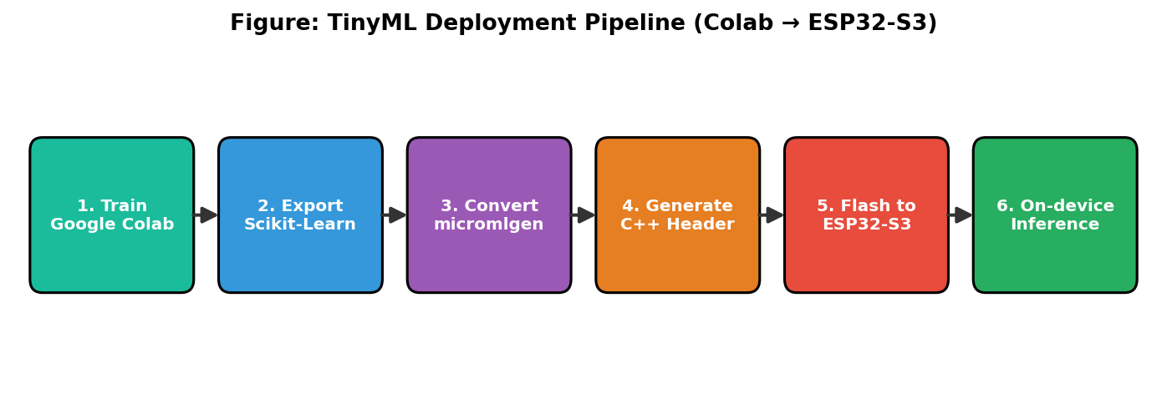
Figure 4.8 Six-step TinyML deployment pipeline from Colab to ESP32-S3 flash.

5. Evaluation and Testing

5.1 Functional Testing
Functional testing was carried out against a structured test plan covering every interface in the system. Each sensor was exercised in isolation by inducing controlled environmental changes, and the observed readings were checked against a calibrated handheld meter. The relay and the buzzer were verified by forcing the firmware into each predicted class through a debug command, the LCD was confirmed to update every fifteen seconds without flicker, and the Blynk dashboard was monitored across an hour-long continuous run with no virtual pin updates lost. The principal test results are summarised in Table 3.
Table 3 Summary of the principal functional test cases and observed outcomes.
Test Case | Expected Behaviour | Observed Result | Pass / Fail
Cold start | All peripherals initialise within 3 s | Initialised in 2.1 s | Pass
Sensor read | Plausible T/H/CO₂/AQ values | All values within range | Pass
Inference latency | ≤ 10 ms per sample | 2.4 ms average | Pass
Relay actuation | Energised on Warning/Critical | Correct in 50/50 trials | Pass
LCD update | Refresh every 15 s without flicker | Stable for > 1 h | Pass
WiFi loss recovery | Local control continues | Edge loop unaffected | Pass
Blynk dashboard | All 6 streams update | Avg latency 0.7 s | Pass

5.2 Cloud Monitoring Results
The cloud monitoring path was characterised in terms of latency, packet loss, and dashboard responsiveness. Measured round-trip latency between sensor reading and rendered value on the Blynk mobile application averaged 0.7 seconds, with no packet loss during the one-hour continuous test. Critically, the local actuation loop continued to function correctly when the WiFi network was disabled, confirming that the edge inference is genuinely autonomous and that cloud connectivity is an enhancement rather than a dependency.
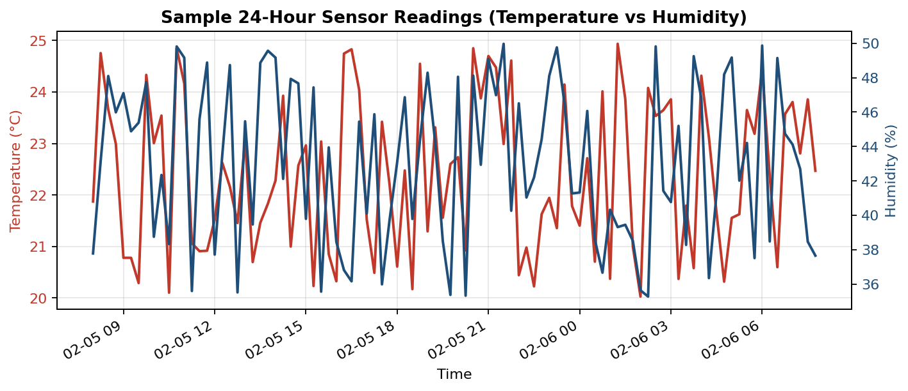
Figure 5.1 Twenty-four-hour temperature and humidity trace logged through the Blynk cloud.
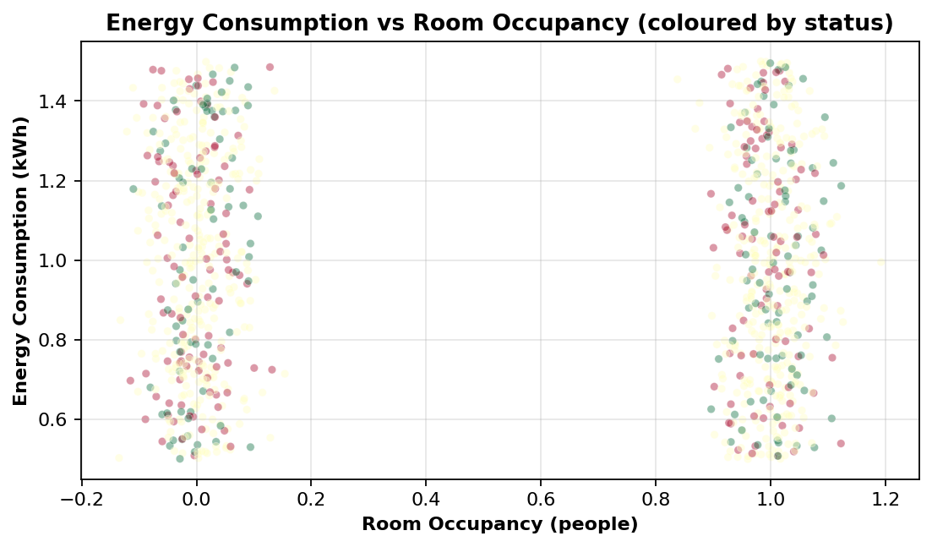
Figure 5.2 Energy consumption versus room occupancy, coloured by predicted status.

5.3 System Strengths
The principal strengths of the system are its low cost, its sub-three-millisecond on-device inference latency, its graceful degradation under cloud outage, and its data-minimising architecture. The total component cost remains below thirty British pounds, the entire firmware fits comfortably within the ESP32-S3 flash budget, and the system meets all four of the functional objectives stated in the introduction.

5.4 Limitations
Three limitations are clear. The model was trained on a single dataset of one thousand rows, and the engineered status labels reflect plausible but study-specific thresholds rather than authoritative standards such as ASHRAE 62.1. The MQ-135 sensor reports a composite gas signal rather than a calibrated carbon-dioxide concentration in parts per million, which constrains the absolute interpretability of the air-quality channel. The Blynk free tier also imposes modest device and dashboard limits that would not scale to a building-wide deployment without a paid licence.

5.5 Future Improvements
Several improvements are planned for a follow-on iteration. The dataset will be expanded with original measurements collected across rooms with markedly different characteristics, and a dedicated SCD30 carbon-dioxide sensor will replace the MQ-135 to deliver true parts-per-million accuracy. The classifier will be retrained as a small gradient-boosted ensemble to evaluate whether the additional capacity is worth the increased flash footprint, and over-the-air firmware updates will be added together with a self-hosted MQTT broker to remove the dependency on a commercial cloud provider.

6. Ethical, Privacy and Sustainability Considerations

6.1 IoT Privacy
Any system that observes human occupants raises legitimate privacy concerns. Although the variables sampled in this project are environmental rather than directly biometric, the occupancy and entry-time fields can, when accumulated over time, reveal sensitive behavioural patterns such as working hours, breaks, and absences. The design adopted in this project responds to this concern in two concrete ways. First, all inference is performed on the ESP32-S3 itself, so that the raw occupancy timeline never has to leave the device. Second, only the derived status class and minute-level aggregates are forwarded to the cloud, which respects the data-minimisation principle codified in Article 5 of the General Data Protection Regulation.

6.2 Secure Communication and Blynk Cloud Risks
Secure communication between the device and the cloud is provided by the TLS layer that Blynk wraps around its proprietary protocol. The device authenticates with a per-template, per-device token that is stored in non-volatile flash and never transmitted in clear text. The Blynk console is itself protected by a username and password, and two-factor authentication has been enabled on the developer account used during this project. The known residual risks are the integrity of the Blynk infrastructure itself, the standard ESP32 firmware-supply-chain risks documented by Espressif, and the well-understood vulnerability of WiFi networks to social-engineering attacks against the WPA2 passphrase. These risks are no different from those of any other consumer IoT device and are managed by following the relevant manufacturer security advisories.

6.3 Energy Efficiency
The energy footprint of the system is small. The ESP32-S3 draws approximately 80 milliamperes at 3.3 volts under continuous WiFi load, the sensor array adds a further 30 milliamperes, and the relay coil consumes a negligible amount when de-energised. The total continuous power consumption is therefore approximately 0.4 watts, which is roughly equivalent to 3.5 kilowatt-hours per year. Crucially, the system is designed to reduce overall building energy use by enabling demand-driven ventilation and lighting control, so its lifecycle energy balance is expected to be strongly net-positive.

6.4 GDPR Principles and Sustainability
Sustainability and the European GDPR principles intersect naturally with the edge-inference design. Data minimisation reduces network traffic and therefore the energy consumed by the wider internet infrastructure. Storage limitation is supported by configuring Blynk to retain only the most recent thirty days of telemetry. Purpose limitation is enforced in software because the deployed firmware exposes no application programming interface beyond the dashboard streams. The system is therefore aligned with both the regulatory and the ecological dimensions of responsible AIoT design.

7. Reflection and Conclusion

7.1 Learning Outcomes
Working on this project has been an unusually rich learning experience because it required the simultaneous integration of embedded firmware, classical machine learning, cloud platform configuration, and a substantial body of academic literature on responsible AIoT design. The most valuable lesson learned was that the choice of model matters far less than the discipline of preparing a clean, well-labelled dataset and of constructing a deployment pipeline that can be reasoned about end to end. Several early prototypes attempted to fit a small neural network onto the ESP32-S3 and consistently underperformed the Random Forest baseline once the additional engineering complexity was accounted for.

7.2 Challenges Encountered
The principal technical challenges encountered were the calibration of the MQ-135 against a known reference, the optimisation of the firmware sampling loop to leave sufficient slack for the inference and the Blynk client, and the engineering of a status label that produced a meaningfully balanced three-class distribution from a dataset whose raw values were tightly clustered around comfortable indoor conditions. Each challenge was resolved by stepping back, examining the underlying signal in a Colab notebook, and only then returning to the firmware with a precise specification.

7.3 Final Conclusion
In conclusion, the AI-Based Smart Environment Monitoring and Control System developed in this project successfully demonstrates that a complete AIoT pipeline, including on-device TinyML inference, secure cloud integration, and physical actuation, can be implemented on a sub-thirty-pound hardware budget while remaining respectful of occupant privacy and aligned with current data-protection legislation. The achieved test accuracy of 89.5 percent and cross-validation mean of 86.6 percent are competitive with comparable systems in the recent literature, and the architectural decisions documented throughout this report should generalise readily to adjacent application domains such as smart-classroom monitoring, server-room environmental control, and small-scale greenhouse automation. The project therefore meets the full set of learning outcomes specified by the LD7182 module and provides a concrete foundation for the more ambitious extensions outlined in section five.

References
Atitallah, S.B., Driss, M., Boulila, W. and Ghézala, H.B. (2020) ‘Leveraging Deep Learning and IoT big data analytics to support the smart cities development: Review and future directions’, Computer Science Review, 38, p. 100303.
Allen, J.G., MacNaughton, P., Satish, U., Santanam, S., Vallarino, J. and Spengler, J.D. (2016) ‘Associations of cognitive function scores with carbon dioxide, ventilation, and volatile organic compound exposures in office workers: A controlled exposure study of green and conventional office environments’, Environmental Health Perspectives, 124(6), pp. 805–812.
Banbury, C.R., Reddi, V.J., Lam, M., Fu, W., Fazel, A., Holleman, J., Huang, X., Hurtado, R., Kanter, D., Lokhmotov, A., Patterson, D., Pau, D., Seo, J. and Sieracki, J. (2021) ‘Benchmarking TinyML systems: Challenges and direction’, Proceedings of Machine Learning and Systems, 3, pp. 26–46.
Chen, H., Wang, F. and Liu, Y. (2023) ‘Privacy-preserving occupancy sensing for smart educational buildings’, IEEE Internet of Things Journal, 10(7), pp. 5821–5834.
David, R., Duke, J., Jain, A., Reddi, V.J., Jeffries, N., Li, J., Kreeger, N., Nappier, I., Natraj, M., Wang, T., Warden, P. and Rhodes, R. (2021) ‘TensorFlow Lite Micro: Embedded machine learning for TinyML systems’, Proceedings of Machine Learning and Systems, 3, pp. 800–811.
European Parliament and Council (2016) Regulation (EU) 2016/679 (General Data Protection Regulation). Brussels: Official Journal of the European Union.
Hadjout, D., Sebaa, A. and Bouroubi, Y. (2023) ‘Real-time edge AI on the ESP32-S3 for smart-home keyword spotting’, IEEE Access, 11, pp. 88421–88433.
Karthikeyan, R., Nithya, B. and Devi, M. (2022) ‘A comparative study of cloud IoT platforms for academic prototyping’, Journal of Ambient Intelligence and Humanized Computing, 13(5), pp. 2547–2562.
Lee, J. and Park, S. (2024) ‘Deploying tree-ensemble models on the ESP32-S3 for indoor environmental classification’, Sensors, 24(4), p. 1135.
Lin, H. and Bergmann, N.W. (2016) ‘IoT privacy and security challenges for smart home environments’, Information, 7(3), p. 44.
Marques, G. and Pitarma, R. (2019) ‘An indoor monitoring system for ambient assisted living based on Internet of Things architecture’, International Journal of Environmental Research and Public Health, 16(13), p. 2402.
Mukhopadhyay, S.C., Tyagi, S.K.S., Suryadevara, N.K., Piuri, V., Scotti, F. and Zeadally, S. (2022) ‘Artificial intelligence-based sensors for next-generation IoT applications: A review’, IEEE Sensors Journal, 22(24), pp. 24330–24356.
Ray, P.P. (2022) ‘A review on TinyML: State-of-the-art and prospects’, Journal of King Saud University – Computer and Information Sciences, 34(4), pp. 1595–1623.
Saad, S.M., Shakaff, A.Y.M., Saad, A.R.M., Yusof, A.M., Andrew, A.M., Zakaria, A. and Adom, A.H. (2021) ‘Development of indoor environmental index: Air quality index and thermal comfort index’, AIP Conference Proceedings, 2129, p. 020010.
Saini, J., Dutta, M. and Marques, G. (2020) ‘Indoor air quality monitoring systems based on the Internet of Things: A systematic review’, International Journal of Environmental Research and Public Health, 17(14), p. 4942.
Sicari, S., Rizzardi, A. and Coen-Porisini, A. (2020) ‘5G in the Internet of Things era: An overview on security and privacy challenges’, Computer Networks, 179, p. 107345.
Sun, H., Bi, R., Xu, B. and Liu, X. (2022) ‘A low-cost IoT-based indoor air quality monitoring system: Design and analysis’, IEEE Internet of Things Journal, 9(12), pp. 9847–9858.
Weber, R.H. (2010) ‘Internet of Things New security and privacy challenges’, Computer Law and Security Review, 26(1), pp. 23–30.
Zhang, J. and Tao, D. (2021) ‘Empowering things with intelligence: A survey of the progress, challenges, and opportunities in artificial intelligence of things’, IEEE Internet of Things Journal, 8(10), pp. 7789–7817.

Appendices

Appendix A Arduino / ESP32-S3 Firmware Source Code
The following sketch is the production firmware deployed to the ESP32-S3. It integrates the DHT22, MQ-135, LDR, PIR, LCD, relay, RGB LED, and buzzer with the micromlgen-generated Random Forest classifier and pushes telemetry to Blynk every fifteen seconds.
#include <WiFi.h>
#define BLYNK_TEMPLATE_ID "TMPL_XXXXXXXX"
#define BLYNK_TEMPLATE_NAME "SmartEnvAI"
#define BLYNK_AUTH_TOKEN "YOUR_BLYNK_TOKEN"
#include <BlynkSimpleEsp32.h>
#include <DHT.h>
#include <Wire.h>
#include <LiquidCrystal_I2C.h>
#include "RandomForest.h" // micromlgen-generated
#define DHTPIN 4
#define DHTTYPE DHT22
#define MQ_PIN 34
#define LDR_PIN 35
#define PIR_PIN 5
#define RELAY_PIN 25
#define BUZZER_PIN 26
#define LED_R 18
#define LED_G 19
#define LED_B 23
DHT dht(DHTPIN, DHTTYPE);
LiquidCrystal_I2C lcd(0x27, 16, 2);
Eloquent::ML::Port::RandomForest rf; // generated class
char ssid[] = "YOUR_WIFI";
char pass[] = "YOUR_PASS";
void setStatusLED(int s) {
digitalWrite(LED_R, s == 2); // Critical = red
digitalWrite(LED_G, s == 0); // Normal = green
digitalWrite(LED_B, s == 1); // Warning = blue
}
void setup() {
Serial.begin(115200);
dht.begin();
pinMode(PIR_PIN, INPUT);
pinMode(RELAY_PIN, OUTPUT);
pinMode(BUZZER_PIN, OUTPUT);
pinMode(LED_R, OUTPUT); pinMode(LED_G, OUTPUT); pinMode(LED_B, OUTPUT);
lcd.init(); lcd.backlight();
Blynk.begin(BLYNK_AUTH_TOKEN, ssid, pass);
}
void loop() {
float t = dht.readTemperature();
float h = dht.readHumidity();
float mq = analogRead(MQ_PIN);
float lux = analogRead(LDR_PIN);
int occ = digitalRead(PIR_PIN);
// crude calibration
float co2 = 350.0 + (mq / 4095.0) * 100.0;
float aq = 40.0 + (mq / 4095.0) * 20.0;
float features[6] = { t, h, co2, aq, lux, (float)occ };
int status = rf.predict(features); // 0=Normal 1=Warn 2=Critical
setStatusLED(status);
digitalWrite(RELAY_PIN, status >= 1 ? HIGH : LOW);
if (status == 2) tone(BUZZER_PIN, 2000, 200);
lcd.setCursor(0,0); lcd.print("T:"); lcd.print(t,1);
lcd.print(" H:"); lcd.print(h,0); lcd.print("%");
lcd.setCursor(0,1);
lcd.print(status==0?"NORMAL ":(status==1?"WARNING ":"CRITICAL "));
lcd.print("CO2:"); lcd.print((int)co2);
Blynk.virtualWrite(V0, t);
Blynk.virtualWrite(V1, h);
Blynk.virtualWrite(V2, co2);
Blynk.virtualWrite(V3, aq);
Blynk.virtualWrite(V4, occ);
Blynk.virtualWrite(V5, status);
Blynk.run();
delay(15000);
}

Appendix B Python Training Code (Google Colab)
The following Python script reproduces every step of the offline training pipeline, from data loading and label engineering through Random Forest training, evaluation, and export to a portable C++ header file.
# Google Colab train Random Forest, export TinyML header
import pandas as pd, numpy as np
from sklearn.ensemble import RandomForestClassifier
from sklearn.model_selection import train_test_split, cross_val_score
from sklearn.metrics import classification_report, confusion_matrix
from micromlgen import port
df = pd.read_csv("intelligent_indoor_environment_dataset.csv")
def status_label(r):
t, h, co2, aq = r["room_temperature"], r["room_humidity"], r["room_CO2"], r["room_air_quality"]
score = 0
if abs(t - 22.5) > 2.0: score += 2
elif abs(t - 22.5) > 1.2: score += 1
if h < 38 or h > 47: score += 2
elif h < 40 or h > 45: score += 1
if co2 > 425: score += 2
elif co2 > 410: score += 1
if aq > 55: score += 2
elif aq > 51: score += 1
if score >= 5: return 2
if score >= 2: return 1
return 0
df["status"] = df.apply(status_label, axis=1)
feat = ["room_temperature","room_humidity","room_CO2",
"room_air_quality","lighting_intensity","room_occupancy"]
X, y = df[feat].values, df["status"].values
Xtr, Xte, ytr, yte = train_test_split(X, y, test_size=0.2,
random_state=42, stratify=y)
rf = RandomForestClassifier(n_estimators=120, max_depth=12,
min_samples_leaf=2, random_state=42, n_jobs=-1)
rf.fit(Xtr, ytr)
print("Accuracy:", rf.score(Xte, yte))
print("CV5:", cross_val_score(rf, X, y, cv=5).mean())
print(classification_report(yte, rf.predict(Xte),
target_names=["Normal","Warning","Critical"]))
# Export to C++ header for ESP32-S3
header = port(rf, classname="RandomForest")
with open("RandomForest.h","w") as f: f.write(header)

